**FinGain Homework**

**FinGain Part 1:**

**Q1)**

1. $4,059,124.28
2. $4,225,086.31

**Q2)**

1. Yes, we can see it increases their expected profit by almost $200,000 dollars.
2. Assumptions:
   1. 8% discount rate
   2. 5% revenue increase per year
   3. Subsidy is only cost
   4. Subsidy causes change in survival rates
   5. All businesses in equal situations

**FinGain Part 2:**

**Q1)** Calculations for non-subsidized clinics below. Calculation in attached excel file.

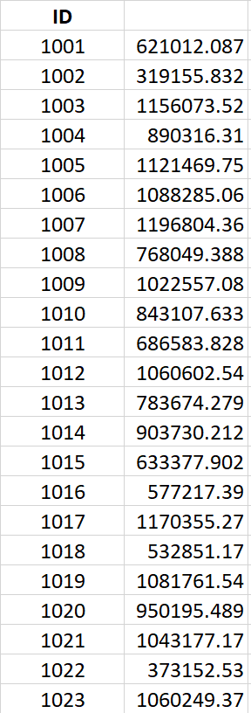

**Q2)** Calculations for subsidized clinics below. Calculation in attached excel file.

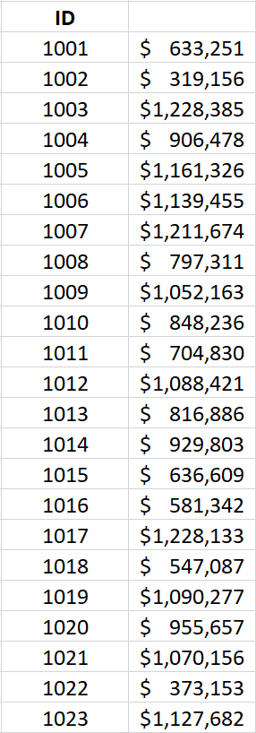

**Q3)** Calculations for ROI below. Calculation in attached excel file.

